AirLine DB Data Model
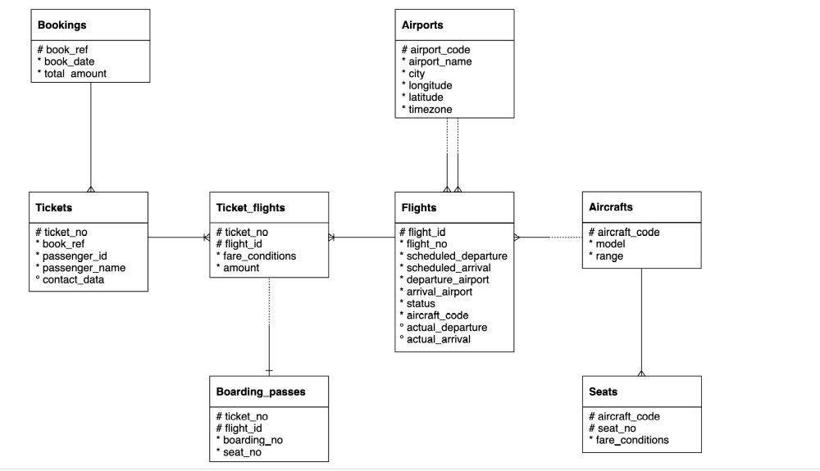

Below are some queries and their Solutions.

- Represent the “book_date” column in “yyyy-mmm-dd” format using Bookings table
Expected output: book_ref, book_date (in “yyyy-mmm-dd” format) , total amount
Answer:
SELECT book_ref, to_char(book_date,'yyyy-mon-dd') as book_date, total_amount
FROM Bookings

- Get the following columns in the exact same sequence.
Expected columns in the output: ticket_no, boarding_no, seat_number, passenger_id, passenger_name.
Answer:
SELECT b.ticket_no, b.boarding_no, b.seat_no as seat_number, t.passenger_id, t.passenger_name
FROM Boarding_passes b
Join tickets t
ON b.ticket_no = t.ticket_no

- Write a query to find the seat number which is least allocated among all the seats?

Answer:
SELECT seat_no
FROM(
SELECT seat_no, count(*) as seat_count
FROM boarding_passes
GROUP BY 1
ORDER BY 2
LIMIT 1
) as seat_no

- In the database, identify the month wise highest paying passenger name and passenger id.
Expected output: Month_name(“mmm-yy” format), passenger_id, passenger_name and total amount

Answer:
WITH monthly_highest_amount as(
SELECT to_char(b.book_date, 'mon-yy') as month_name, t.passenger_id, t.passenger_name,b.total_amount,
ROW_NUMBER() OVER(partition by to_char(b.book_date, 'mon-yy') ORDER BY b.total_amount DESC) as row
FROM bookings b
JOIN tickets t
ON b.book_ref = t.book_ref
)
SELECT month_name, passenger_id, passenger_name, total_amount
FROM monthly_highest_amount
WHERE row = 1
ORDER BY month_name

- In the database, identify the month wise least paying passenger name and passenger id?
Expected output: Month_name(“mmm-yy” format), passenger_id, passenger_name and total amount

Answer:
WITH monthly_least_amount as(
SELECT to_char(b.book_date, 'mon-yy') as month_name, t.passenger_id, t.passenger_name,b.total_amount,
ROW_NUMBER() OVER(partition by to_char(b.book_date, 'mon-yy') ORDER BY b.total_amount ASC) as row
FROM bookings b
JOIN tickets t
ON b.book_ref = t.book_ref
)

SELECT month_name, passenger_id, passenger_name, total_amount
FROM monthly_least_amount
WHERE row = 1
ORDER BY month_name

- Identify the travel details of non stop journeys or return journeys (having more than 1 flight).
Expected Output: Passenger_id, passenger_name, ticket_number and flight count.

Answer:
SELECT t.passenger_id, t.passenger_name, t.ticket_no, count(f.flight_id) as flight_count
FROM tickets t
JOIN ticket_flights f
ON t.ticket_no = f.ticket_no
GROUP BY 1,2,3
HAVING count(f.flight_id) = 1 or count(f.flight_id) > 1

- How many tickets are there without boarding passes?
Expected Output: just one number is required.

Answer:
SELECT count(*) as ticket_count_without_boarding_pass
FROM tickets t
LEFT JOIN boarding_passes b
ON t.ticket_no = b.ticket_no
WHERE b.ticket_no is NULL

- Identify details of the longest flight (using flights table)?
Expected Output: Flight number, departure airport, arrival airport, aircraft code and durations.

Answer:
SELECT flight_no, departure_airport, arrival_airport, aircraft_code, (scheduled_arrival - scheduled_departure) as duration
FROM flights
ORDER BY duration DESC
LIMIT 1

- Identify details of all the morning flights (morning means between 6AM to 11 AM, using flights table)?
Expected output: flight_id, flight_number, scheduled_departure, scheduled_arrival and timings.

Answer:
SELECT flight_id, flight_no, scheduled_departure, scheduled_arrival, CAST(scheduled_departure AS time) as timing
FROM flights
WHERE CAST(scheduled_departure AS time) BETWEEN '06:00:00' AND'11:00:00'

- Identify the earliest morning flight available from every airport.
Expected output: flight_id, flight_number, scheduled_departure, scheduled_arrival, departure airport and timings.
Answer:
WITH early_morning_flight as (
SELECT flight_id, flight_no, scheduled_departure, scheduled_arrival, departure_airport,
cast(scheduled_departure as time) as timing, row_number() over(partition by departure_airport order by scheduled_departure) as rownumber
FROM flights
WHERE CAST(scheduled_departure as time) BETWEEN '06:00:00' AND '11:00:00')
SELECT flight_id, flight_no, scheduled_departure, scheduled_arrival, departure_airport, timing
FROM early_morning_flight
WHERE rownumber = 1

- Questions: Find list of airport codes in Europe/Moscow timezone
Expected Output: Airport_code.

Answer:
SELECT DISTINCT(airport_code)
FROM airports
WHERE timezone = 'Europe/Moscow'

- Write a query to get the count of seats in various fare condition for every aircraft code?
Expected Outputs: Aircraft_code, fare_conditions ,seat count

Answer:
SELECT aircraft_code, fare_conditions, count(*) as seat_count
FROM seats
GROUP BY 1,2
ORDER BY 1,2

- How many aircrafts codes have at least one Business class seats?
Expected Output : Count of aircraft codes

Answer:
SELECT count(DISTINCT aircraft_code) as count_aircrafts
FROM seats
WHERE fare_conditions = 'Business'

- Find out the name of the airport having maximum number of departure flight
Expected Output : Airport_name

Answer:
SELECT airport_name
FROM airports
WHERE airport_code = (
SELECT departure_airport
FROM flights
GROUP BY departure_airport
ORDER BY count(*) DESC
LIMIT 1
)
- Find out the name of the airport having least number of scheduled departure flights
Expected Output : Airport_name

Answer:
SELECT airport_name
FROM airports
WHERE airport_code = (
SELECT departure_airport
FROM flights
GROUP BY departure_airport
ORDER BY count(*) ASC
LIMIT 1
)

- How many flights from ‘DME’ airport don’t have actual departure?
Expected Output : Flight Count

Answer:
SELECT count(*) as flight_count
FROM flights
WHERE departure_airport = 'DME' AND actual_departure IS NULL

- Identify flight ids having range between 3000 to 6000
Expected Output : Flight_Number , aircraft_code, ranges

Answer:
SELECT f.flight_no, f.aircraft_code, a.range
FROM flights as f
JOIN aircrafts as a
ON f.aircraft_code = a.aircraft_code
WHERE a.range between 3000 and 6000
GROUP BY 1,2,3
ORDER BY 3

- Write a query to get the count of flights flying between URS and KUF?
Expected Output : Flight_count

Answer:
SELECT count(*) as flight_count
FROM flights
WHERE departure_airport = 'URS' AND arrival_airport = 'KUF'

- Write a query to get the count of flights flying from either from NOZ or KRR?
Expected Output : Flight count

Answer:
SELECT count(*) as flight_count
FROM flights
WHERE departure_airport = 'NOZ' OR departure_airport = 'KRR'

- Write a query to get the count of flights flying from KZN,DME,NBC,NJC,GDX,SGC,VKO,ROV
Expected Output : Departure airport ,count of flights flying from these airports.

Answer:
SELECT departure_airport, count(*) as flight_count
FROM flights
WHERE departure_airport IN ('KZN','DME','NBC','NJC','GDX','SGC','VKO','ROV')
GROUP BY 1
ORDER BY flight_count

- Write a query to extract flight details having range between 3000 and 6000 and flying from DME
Expected Output :Flight_no,aircraft_code,range,departure_airport

Answer:
SELECT f.flight_no, f.aircraft_code, a.range, f.departure_airport
FROM flights as f
JOIN aircrafts as a
ON f.aircraft_code = a.aircraft_code
WHERE a.range BETWEEN 3000 AND 6000 AND departure_airport = 'DME'
GROUP BY f.flight_no, f.aircraft_code, a.range, f.departure_airport
ORDER BY a.range

- Find the list of flight ids which are using aircrafts from “Airbus” company and got cancelled or delayed
Expected Output : Flight_id,aircraft_model

Answer:
SELECT f.flight_id, a.model as aircraft_model
FROM flights as f
JOIN aircrafts as a
ON f.aircraft_code = a.aircraft_code
WHERE a.model like '%Airbus%' AND (f.status = 'Cancelled' OR f.status = 'Delayed')

- Find the list of flight ids which are using aircrafts from “Boeing” company and got cancelled or delayed
Expected Output : Flight_id,aircraft_model

Answer:
SELECT f.flight_id, a.model
FROM flights as f
JOIN aircrafts as a
ON f.aircraft_code = a.aircraft_code
WHERE a.model like '%Boeing%' and (f.status = 'Cancelled' OR f.status = 'Delayed')

- Which airport(name) has most cancelled flights (arriving)?
Expected Output : Airport_name
Answer:
SELECT a.airport_name
FROM airports as a
JOIN flights as f
ON a.airport_code = f.arrival_airport
WHERE f.status = 'Cancelled'
GROUP BY 1
ORDER BY COUNT(*) DESC
LIMIT 1

- Identify flight ids which are using “Airbus aircrafts”
Expected Output : Flight_id,aircraft_model

Answer:
SELECT f.flight_id, a.model
FROM flights as f
JOIN aircrafts as a
ON f.aircraft_code = a.aircraft_code
WHERE a.model like '%Airbus%'

- Identify date-wise last flight id flying from every airport?
Expected Output: Flight_id,flight_number,schedule_departure,departure_airport
Answer:
WITH last_flight as (
SELECT f.flight_id,
f.flight_no,
f.scheduled_departure, f.departure_airport,
MAX(scheduled_departure) OVER (partition by departure_airport, DATE(scheduled_departure)) as max_scheduled_departure
FROM flights as f
)

SELECT flight_id, flight_no, scheduled_departure, departure_airport
FROM last_flight
WHERE scheduled_departure = max_scheduled_departure
ORDER BY 2

- Identify list of customers who will get the refund due to cancellation of the flights and how much amount they will get?
Expected Output : Passenger_name,total_refund.

Answer:
SELECT passenger_name, SUM(tf.amount) as total_refund
FROM tickets as t
LEFT JOIN ticket_flights as tf
ON t.ticket_no = tf.ticket_no
JOIN flights f
ON tf.flight_id = f.flight_id
WHERE Status = 'Cancelled'
GROUP BY 1

- Identify date wise first cancelled flight id flying for every airport?
Expected Output : Flight_id,flight_number,schedule_departure,departure_airport

Answer:
SELECT flight_id, flight_no, scheduled_departure, departure_airport
FROM (
SELECT
flight_id, flight_no, scheduled_departure, departure_airport,
ROW_NUMBER() OVER(PARTITION BY departure_airport ORDER BY scheduled_departure ASC) AS row
FROM flights
WHERE status='Cancelled') AS table1
WHERE row = 1
ORDER BY departure_airport, scheduled_departure

- Identify list of Airbus flight ids which got cancelled.
Expected Output : Flight_id

Answer:
SELECT f.flight_id
FROM flights f
JOIN aircrafts a
ON f.aircraft_code = a.aircraft_code
WHERE a.model like '%Airbus%' AND f.status = 'Cancelled'

- Identify list of flight ids having highest range.
Expected Output : Flight_no, range

Answer:
SELECT f.flight_no, max(a.range) as range
FROM flights f
JOIN aircrafts a
ON f.aircraft_code = a.aircraft_code
GROUP BY flight_no

